Modbus Master Custom Device Readme

Introduction
The Modbus Master Custom Device was designed with the intent to give Veristand the ability to act as a Modbus Master.

Configuration

Configuring a TCP Master
To configure a TCP Master:
- In the System Explorer, right-click on the “Custom Devices“ group in VeriStand and select National Instruments >> Modbus Master to Slave. This will add an instance of the Custom Device to your project.
- Select your new Custom Device instance, and verify that “Interface Type“ is set to “TCP Master“.
- Type the IP Address of your slave device, the communication port that your device communicates over, and the network timeout.

Configuring a Serial Master
To Configure a Serial Master:
- In the System Explorer, right-click on the “Custom Devices“ group in VeriStand and select National Instruments >> Modbus Master to Slave. This will add an instance of the Custom Device to your project.
- Select your new Custom Device instance, and verify that “Interface Type“ is set to “Serial Master“.
- Enter the VISA Resource Name for the communications port that your Modbus connection will use.
NOTE: The dropdown only selects a valid port if your system will be deployed locally. For remote targets, you can find the correct VISA resource name under the name property. In the example below, you would use “COM1“ with no quotations.
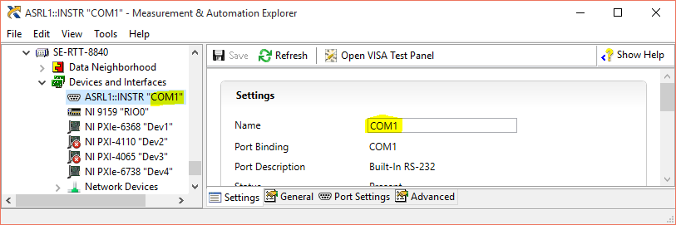
- Set the unit ID of the slave device.
- Set the serial settings of the slave device.
NOTE: The Data Bits and Stop Bits parameters are determined by the parity and serial type per the Modbus standard.

Shared Settings

Maximum Channels per Read
The Modbus Master Custom Device automatically detects Inputs that are assigned to contiguous address spaces and reads them in a group. The Maximum Channels per Read parameter sets the largest group of contiguous tags that will be created.
In general, a larger Maximum Channels per Read value means that less network traffic will be used for fetching data.

Read Refresh Rate (ms)
This is the rate which the device will poll the slave for new data. The device will never poll faster than this rate, but reading all of the channels can take longer than the specified rate. You can monitor whether this rate is achieved at runtime by monitoring the Late Read Count channel.

Reading from a Modbus Slave
The Modbus Master will poll the slave at the rate set in Read Refresh Rate (ms).

Coils
While coils are typically used to write 1-bit values from the Master to the Slave, they can be set to function in the other direction as well. To add a coil to read data from the Slave device:
- Right-click and select “Add Coil“
- Select the newly-created coil, and verify that the Name, Address, and Description are correct.
- In the top-right corner, set the selector to Read.

Discrete Inputs
Discrete Inputs are used to transfer 1-bit values from the Slave to the Master, and can not be configured to communicate from the Master to the Slave. To add a Discrete Input to read data from the Slave device:
- Right-click and select “Add Discrete Input“
- Select the newly-created Discrete Input, and verify that the Name, Address, and Description are correct.

Holding Registers
While Holding Registers are typically used to write 16-bit values from the Master to the Slave, they can be set to function in the other direction as well. To add a Holding Register to read data from the Slave device:
- Right-click and select “Add Holding Register“
- Select the newly-created Holding Register, and verify that the Name, Address, and Description are correct.
- In the top-right corner, set the selector to Read.

Input Registers
Input Registers are used to transfer 16-bit values from the Slave to the Master, and can not be configured to communicate from the Master to the Slave. To add a Input Register to read data from the Slave device:
- Right-click and select “Add Input Register“
- Select the newly-created Input Register, and verify that the Name, Address, and Description are correct.

Writing to a Modbus Slave

Coils
Coils are used to write 1-bit values from the Master to the Slave. To add a Coil to write data to the Slave device:
- Right-click and select “Add Coil“
- Select the newly-created coil, and verify that the Name, Address, and Description are correct.
- In the top-right corner, set the selector to Write.

Discrete Inputs
Discrete Inputs are only able to write from the Slave to the Master, and cannot be configured to write from the Master to the Slave.

Holding Registers
Holding Registers are used to write 16-bit values from the Master to the Slave. To add a Holding Register to write data to the Slave device:
- Right-click and select “Add Holding Register“
- Select the newly-created Holding Register, and verify that the Name, Address, and Description are correct.
- In the top-right corner, set the selector to Write.

Input Registers
Input Registers are only able to write from the Slave to the Master, and cannot be configured to write from the Master to the Slave.

Rebuilding the Custom Device
If you desire to modify the custom device or need to rebuild the Engine or System Configuration you will need to rebuild the System Configuration and Engine Libraries.

Rebuilding All
A utility is included in the project at <Root> \Modbus-Custom-Device-v2\Source\ Modbus Master Custom Device - Windows.lvproj that will build the System Configuration and Engines for all of the target types.
- Open the project, and expand the Utility virtual folder.
- Open the Build All VI.
- Select the targets you would like to build and run the VI.
This will build all of the selected Build Specifications.

Rebuilding the System Configuration
The system configuration is for Windows, so the build specification is located under
<Root> \Modbus-Custom-Device-v2\Source\ Modbus Master Custom Device - Windows.lvproj
- Open the project, and expand Build Specifications under My Computer.
- Right-click on Configuration Release and select Build.

Rebuilding the Engines
The Modbus Master Custom Device uses the LabVIEW Modbus API Documentation for this library can be found at the following location:
https://decibel.ni.com/content/docs/DOC-30140
This library provides the functionality we need, but presents a challenge. The library is Object-Oriented, and Veristand uses .llb files, which don’t support objects. To get around this, we compile the source code for the Modbus API in a Packed Project Library (PPL), and include that in our distribution.
This creates a new challenge, in that PPLs are target-type specific. This means that we need a version for each OS we want to support this device on. Builds for multiple targets have been created and can be downloaded from the following repository:
https://github.com/NIVeriStandAdd-Ons/Modbus-Custom-Device-PPL

This should be at the same folder depth as the Modbus Custom Device v2 root folder as shown below:
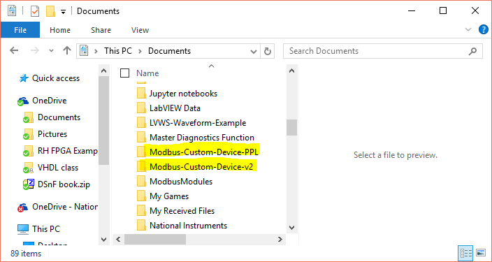
When each engine specification is built, it calls a pre-compile VI that copies the right version of this library in to the source directory.
To rebuild the engine for a specific target, follow these steps:
- Download and install the Modus Custom Device PPL at the location shown above.
- Open the project for your target type from <Root> \Modbus-Custom-Device-v2\Source\ Modbus Master Custom Device - <Target>.lvproj
- Expand Build Specifications under the target.
- Right-click on Engine Release and select Build.

